Preliminary Analysis - Pycase

Harry George
2011-11-24

Copyright
Preliminary Analysis Template by Harry George is licensed under a Creative Commons Attribution-ShareAlike 3.0 Unported License.
Table of Contents
1Introduction 1
1.1Context 1
1.2Problem Statement 1
1.3Results Summary 1
1.4Glossary 1
2Project Context 1
2.1Team Structure 1
2.2Information Sites 1
2.3Assumptions 1
2.4Management Issues 1
2.5Parking Lot 1
3Architectural Context 1
3.1Literature Search 1
3.2Organization Context 1
3.3Information Context 1
3.4Process Context 1
3.5Application Context 1
3.6Geographic Context 1
4Project Model 1
4.1User Requirements 1
4.2Information Model 1
4.3Process Model 1
4.3.1Establish governance 1
4.3.1.1Description 1
4.3.1.2Preconditions 1
4.3.1.3Postconditions 1
4.3.1.4Process 1
4.3.2Establish toolsuite 1
4.3.2.1Description 1
4.3.2.2Preconditions 1
4.3.2.3Postconditions 1
4.3.2.4Process 1
4.3.3Establish toolsuite 1
4.3.3.1Description 1
4.3.3.2Preconditions 1
4.3.3.3Postconditions 1
4.3.3.4Process 1
4.3.4Manage conceptual model 1
4.3.4.1Description 1
4.3.4.2Preconditions 1
4.3.4.3Postconditions 1
4.3.4.4Process 1
4.3.5Manage logical model 1
4.3.5.1Description 1
4.3.5.2Preconditions 1
4.3.5.3Postconditions 1
4.3.5.4Process 1
4.3.6Manage physical model 1
4.3.6.1Description 1
4.3.6.2Preconditions 1
4.3.6.3Postconditions 1
4.3.6.4Process 1
4.3.7Support Preliminary Design Review (PDR) 1
4.3.7.1Description 1
4.3.7.2Preconditions 1
4.3.7.3Postconditions 1
4.3.7.4Process 1
4.3.8Support Critical Design Review (CDR) 1
4.3.8.1Description 1
4.3.8.2Preconditions 1
4.3.8.3Postconditions 1
4.3.8.4Process 1
4.3.9Do impact analysis for delta in conceptual data model 1
4.3.9.1Description 1
4.3.9.2Preconditions 1
4.3.9.3Postconditions 1
4.3.9.4Process 1
4.3.10Do impact analysis for delta in physical model 1
4.3.10.1Description 1
4.3.10.2Preconditions 1
4.3.10.3Postconditions 1
4.3.10.4Process 1
4.3.11Search for overlapping implementations of same data. 1
4.3.11.1Description 1
4.3.11.2Preconditions 1
4.3.11.3Postconditions 1
4.3.11.4Process 1
5Implementation Strategy 1
5.1Alternatives Analysis 1
5.1.1Factors 1
5.1.2Candidates 1
5.1.2.1As-Is 1
5.1.2.2As-Is with workarounds 1
5.1.2.3Vendor-supplied integration – IBM Jazz 1
5.1.2.4Pycase 1
5.1.3Analysis 1
5.1.4Recommendation 1
6Implementation Architecture 1
6.1Data Architecture 1
6.2Application Architecture 1
6.3Human-Computer Interface 1
6.4Infrastructure Architecture 1
7Testing 1
7.1Test Strategy 1
7.2Test Suite 1

Introduction

Context
In Software Engineering (SWE) we need to collect/create abstract models and systematically enrich/rewrite them until they become the executable solution. Much of this would appear to be automatable, but it has proven difficult for years (“Programmer's Assistant”, “Visual Programming”, “End User Programming”). Further, many efforts are platform-specific, vendor-specific, language-specific, or otherwise not suited to OSS projects/

Problem Statement
Obtain/build a toolsuite to auomate or to assist SWE lifecycle, using OSS tools.

Results Summary

Glossary
OSI
Open Source Initiative. Web site for OSS licenses.
OSS
Open Source Software; specifically OSI-compliant
SE
Systems Engineering
SWE
Software Engineering

Project Context

Team Structure
Sponsor | N/A
Data Owner  (responsible for data content) | Harry George
System Owner  (responsible for manual-and-automated system to manage data) | Harry George
System Manager  (deputized by system owner to manager this project) | Harry George
Project Manager  (deputized by system manager to orchestrate schedules, resources, meetings, gentle prodding) | Harry George
Systems Architect  (responsible for conceptual modeling, transition to logical modeling, external interfaces, and implementation strategy) | Harry George
SME (Subject Matter Expert ) | Harry George
SME
SME
If PA says there is to be an implementation project, ...
Application Manager
(responsible for development team)
IT Project Manager
(deputized by application manager to orchestrate schedules, resources, meetings, gentle prodding)
Technical Lead
(responsible for internal structure and development team's results)
DBA
(if needed; responsible for database installation and configuration; and for logical-to-physical schema mapping)
Systems admin
(responsible for servers, service deamon scripts, firewalls, hardware resource allocation)
Developer
Developer
Developer

Information Sites
(websites, wikis, etc.)
http://www.seanet.com/~hgg9140/comp/index.html

Assumptions
(as needed)

Management Issues
(Can't be solved here)

Parking Lot
(out of scope for now)

Architectural Context

Literature Search
(External and internal search for project's domain,vocabulary, theory, potential off-the-shelf solutions)
Architecture Frameworks
IEEE 1471: http://standards.ieee.org/findstds/standard/1471-2000.html
TOGAF: http://pubs.opengroup.org/architecture/togaf8-doc/arch/
DODAF: http://dodcio.defense.gov/sites/dodaf20/
Zachamnn: http://en.wikipedia.org/wiki/Zachman_Framework

Modeling paradigms
UML: http://www.uml.org/
SysML: http://www.sysml.org/
Modelica: https://modelica.org/
OOA&D: http://en.wikipedia.org/wiki/Object-oriented_analysis_and_design
SADT: http://en.wikipedia.org/wiki/Structured_Analysis_and_Design_Technique
IDEF: http://en.wikipedia.org/wiki/IDEF

Programmer's Assistant Efforts
History http://www.google.com/url?sa=t&rct=j&q=programmers%20assistant%20hisotry&source=web&cd=8&sqi=2&ved=0CFYQFjAH&url=http%3A%2F%2Fwww.softwarepreservation.org%2Fprojects%2FLISP%2Finterlisp%2FTeitelman-FCJJ1972.pdf&ei=7Gj2TqCxK-qviQLQuLiYDQ&usg=AFQjCNGXVkC7eaZkVNqvfIeFtdrOEZUmgg&cad=rja
Visual programming: http://www.readwriteweb.com/hack/2010/11/visual-programming.php

Automated programming history: www.merl.com/papers/docs/TR92-04.pdf
Automated programming: http://en.wikipedia.org/wiki/Automatic_programming

Organization Context
(who are the players? org trees,org charts, standards bodies, etc.)
Each OSS project chooses its own mechanisms. Some project choose to live within a umbrella context that has specific rules and toolsets (e.g., Apache Foundation's Java projects).
If the OSS project is to be taken seriously by a potential user (e.g., governmental body, corporation), then it may also conform to or be compliant with established standards bodies. These include:
IEEE: http://www.ieee.org/index.html
NIST: http://www.nist.gov/index.html
ISO: http://www.iso.org/iso/home.html (see Concept Database; search software engineering)
OMG (consortium supporting standards which in turn support commercial ventures): http://www.omg.org/

Information Context
(Implementation-independent data model context, if known)
“Architecture Framework” covers large portfolios of projects, and re-use of models among them. The IEEE 1471 metamodel is the start point. DODAF's metamodel is a useful next step. UML 2.x is a usefully detailed model for a specific project but doesn't speak to frameworks. Next step is to VHLL (Very High Level Languages), including SQL and XML for data and Python for data/process/object.
A programmer's assistant (or at least an architect's assistant) needs to be competent at all these levels – with an integrated metamodel and workflow. There are no candidates for the whole story.

Process Context
(Implementation-independent process model, if known. Also command media.)
IEEE 1471 and DODAF indicate the metamodel (data model) is understood and ready for standardization, whereas process modeling is not. OODA, SADT, IDEF, UML provide modeling mechanisms but not explicitly process steps. Process steps tend to be left to software engineering (SWE) textbooks. And, because SWE inherits many of its ideas from systems engineering (SE), those processes are also relevant.

INCOSE (SE's main body) has a handbook, and a primer:
http://www.incose.org/ProductsPubs/products/sehandbook.aspx.
http://www.incose.org/ProductsPubs/pdf/SEPrimerAIAA-INCOSE_1997-08.pdf
Process:
Plan And Organize The Technical Aspects . . . . . . . . . . . . .
Analyze And Understand The Problem Before
Attempting To Solve It . . . . . . . . . . . . . . . . . . . . . . . . . . . . . .
Assess And Select Alternatives . . . . . . . . . . . . . . . . . . . . .
Define And Verify The Solution . . . . . . . . . . . . . . . . . . . . . . .
Resources:
Requirements Management – Focusing On
Stakeholder Needs And Expectations . . . . . . . . . . . . . . . .
Risk Management – Identifying And Controlling
“Surprises” Before Harm Is Done To The Project . . . . . .
Technical Reviews – How Are We Doing?

TOGAF proposes processes as an extension to its IEEE 1471 efforts: http://pubs.opengroup.org/architecture/togaf9-doc/arch/
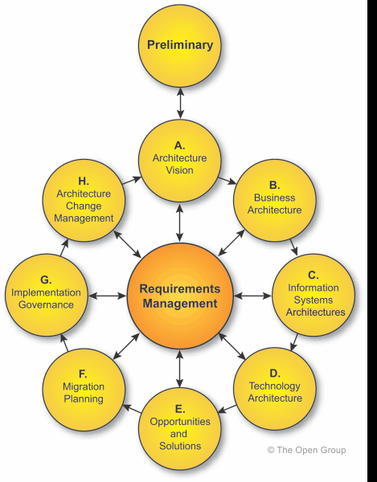

OpenSDLC: http://opensdlc.org/mediawiki/index.php?title=Main_Page
Project Lifecycle Phases
The SDLC project lifecycle consists of five phases (see Figure) that are defined as follows:
- Release Planning Phase: During the release planning phase, feasibility studies are performed, user requirements are defined, high level estimates are produced and compared to forecasts of the performing organization’s capacity, business cases are prepared and all possible projects are prioritized to assist in project selection. Scenarios may be created to investigate possible combinations of projects (features) that would be affordable based on the capacity of the performing organization. Many of these activities are performed on an ongoing basis as new customer requests are submitted.
- Definition Phase: During the definition phase, the performing organization creates a statement of requirements based on the user requirements defined during the concept phase. The performing organization then obtains approval from the contracting organization that the user requirements are accurately reflected in the statement of requirements. The performing organization also allocates the approved requirements to the architectural elements of the system (or subsystem) and performs high level planning for the remaining project phases. In addition, the contracting organization finalizes the deployment objectives for the project product.
- Development Phase: During the development phase, the performing organization finalizes the Detail Plan that provides the detailed schedule and resource assignments. Additionally, the performing organization designs, builds and tests the project product according to the allocated requirements. Each performing organization may have its own unique development lifecycle for the development phase of the project.
- Validation Phase: During the validation phase, the performing organization tests the project product at an overall system-level to ensure compliance. Some levels of testing may be performed in the development phase. The distinction between development phase testing and validation phase testing is that validation phase testing is performed on an integrated product build.
- Deployment Phase: During the deployment phase, the project product is installed in customer systems. Deployment will usually involve an FOA deployment that may be followed by one or more controlled rollout deployments before the project product is declared to be generally available. Deployment may be the responsibility of the performing organization, the contracting organization or a combination of the two.

Application Context
(Applications-and-interfaces context, if known. Approximately DFD Level 0 or high level UML Component view)
This is an unsolved domain. There have been attempts at Computer Aided Software Engineering (CASE), with modeling tools, editors, Programmer Assistants, Integrated Development Environments, and even model repositories. However, none of them actually supports the full process as seen by a systems architect or application developers. There tend to be many tools, most claiming to cover all aspects of the task and therefore not interested in easy integration with other tools. An architect has to craft glueware to tie them together, and often has to create datamarts to make the data accessible in a unified manner.
A Google search for “systems architecture images” will give a full page of pictures, each with some relevance. The classic Zachmann framework (available on that page) doesn't provide tools, but if you can imagine at least one tool in each cell, and at least one glueware effort for each cell boundary/interface, then you have the idea.
For a purely OSS world, we can give representative tools:

Documentation
Web-based, wiki-based sites. OpenOffice/LibreOffice. Documentation markups including TeX, LaTeX, Docbook, POD, Pdx, reStructured Text.
Generic diagrams
Xfig, Dia, Inkscape, OpenOffice/LibreOffice Draw, Graphviz (autogenerated)
UML models
Dia (old), BOUML (defunct), DOUML (still-born), Eclipse+Papyrus (up-to-date, but Java and thus vast, complex, and slow).
Code mgmt
RCS (old), CVS (old), SVN (current), Git (distributed, complex), Mercury (distributed, less complex)
Editors
vim (true believers), emacs (true believers), scite, notepad++ (scite for MS Windows), eclipse, …..
Languages (and compilers)
C (gcc), C++ (gcc), FORTRAN (gcc), Perl (perl), Python (python).
Databases
Postgresql, MySQL (comes and goes as OSS), SQLite, ZODB (OODBMS), MongoDB (noSQL)
GUI toolkit – thick client
gtk, qt, wx, flt. All of these have Python bindings.
GUI toolkit - web-based
Web CGI or WSGI. Pylons, Pyramid, TurboGears, Django. Google Web Toolkit.

None of these tools deliberately obfuscates its storage data format, but it is still non-trivial to develop reader/writer adapters. “adapter” must be part of the Pycase architecture.

Geographic Context
(Maps or other indication of distances and boundaries)
OSS projects are Internet-wide, thus touching all of Earth, and working in the context of all political boundaries.

Project Model

User Requirements
(In whatever format available; used as acceptance tests for Information and Process models)
- Manage portfolios of domains (“business segments”) each with its own change control, blockpoints, and roadmaps.
- Support reuse of architectural components across blockpoints within a domain
- Support reuse of architectural components across domains.
- Within domain, capture conceptual/logical/physical models of data and process.
- Provide traceability up and down the conceptual/logical/physical chain
- Support integrity checking across model views (e.g., data to process to organization)
- Support ad hoc analyses across the whole suite of models. May require a unified repository.
- Facilitate authoring, e.g., by model-specific tools which are then connected to a unified repository.
- Use all the above to assist autogeneration of software systems using Model View Controller or similar architecture which facilitates “plug compatible” implementation.
Data becomes database schema or XML schema
Data drives Editing interfaces.
Process drives algorithms

Information Model
(Implementation-independent data model, extended as needed to cover process)
(UML Class diagrams with narrative)
Even if we accept the various metamodels in Information Context, we find we must devise our own working-level metamodel for this project. We have done so using IEE 1471 terms in many cases, building a BOUML “UML Class View”:
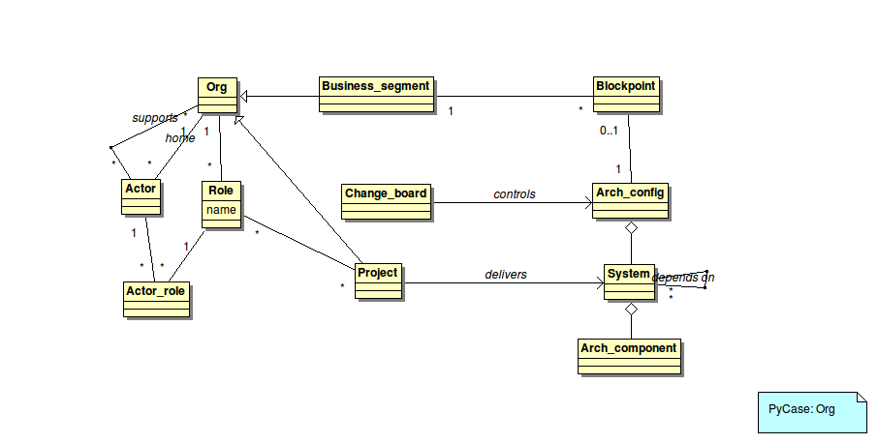
Orgs have Roles which are performed by various Actors. Actors typically have a home Org, and may support many Orgs. One type of Org is a Business segment, which is a politically cohesive unit which has a series of changes in its architecture. A specific architectural configuration (Arch_variant) is chosen for a specific Blockpoint. The Arch_variant is assembled from Systems which in turn are assembled from Arch_components. Both Systems and Arch_components can be re-used in different Arch_variants.
A Change_board controls the contents of the Arch_variant, based on what Systems have been made available via Projects. Projects in turn are types of Orgs, and have Roles to be performed by Actors.

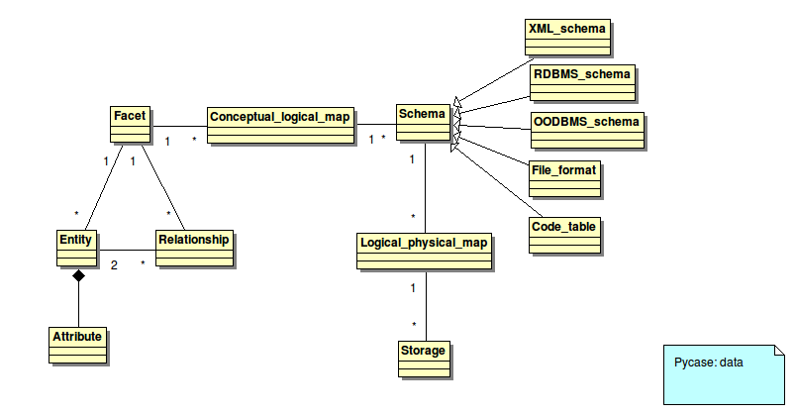
A data Facet is a unit of conceptual data modeling which subsumes a set of Entities (with their Attributes) and Relationships. The Facet is mapped to 1 or more logical Schemas, which are then mapped to physical implementations as Storage.

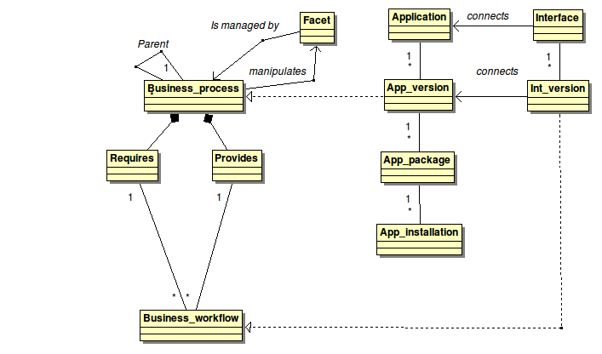

A Business_Process (which may be decomposed) manages or manipulates a Facet. The Business_process Requires some inputs and Provides some outputs. Business_workflows ties together inputs and outputs to perform business functions.
At a notional level, it may be useful to recognize that Interfaces connect Applications. However, at the level required to control Blockpoints, App_versions and Int_versions must be known, and therefore they are the Arch_components assembled to make an Arch_variant. Thus, a Business process is realized via an App_version, and a Business_workflow is realized via an Int_version.
Just knowing the App_versions is not enough. App_versions may be released in multiple App_packages (e.g., for 32-bitivs 64-bit). And the App_packages may be installed as App_installations many places.

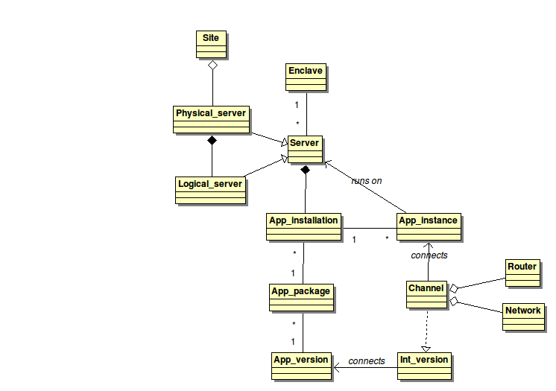
In a physical Site, we can assemble multiple Physical_servers. A Physical_server in turn may host many Logical_servers. Whether physical or logical, Servers host App_installations. The loaded and running form of an App_installation is an App_instance. App_instances communicate via Channels, which are physical realizations of Int_versions. Channels in turn are assembled (perhaps on the fly) from Routers and Network

Process Model
(Implementation-independent process model,extended as needed to cover data and function)
(Use Case diagram, Sequence Diagram)
Using the SE steps, and the TOGAF ADM wheel, and practical experience in systems architecture, we identify these processes:

Establish governance

Description
Determine Business_segments and Change_boards participating in effort.

Preconditions

Postconditions
(All User Rqmts should be covered or confirmed here)

Process
(Steps, stated in terms of traversing and manipulating the Information Model)

Establish toolsuite

Description
Obtain/build adequate tools.

Preconditions

Postconditions
(All User Rqmts should be covered or confirmed here)

Process
(Steps, stated in terms of traversing and manipulating the Information Model)

Establish toolsuite

Description
Obtain/build adequate tools.

Preconditions

Postconditions
(All User Rqmts should be covered or confirmed here)

Process
(Steps, stated in terms of traversing and manipulating the Information Model)

Manage conceptual model

Description
Author, collect, analyze, revise, coordinate conceptual Data and Process models

Preconditions

Postconditions
(All User Rqmts should be covered or confirmed here)

Process
(Steps, stated in terms of traversing and manipulating the Information Model)

Manage logical model

Description
Author, collect, analyze, revise, coordinate logical Data, Process and Org models. Maintain mapping to conceptual model.

Preconditions

Postconditions
(All User Rqmts should be covered or confirmed here)

Process
(Steps, stated in terms of traversing and manipulating the Information Model)

Manage physical model

Description
Author, collect, analyze, revise, coordinate physical Data, Process, Org, and Infrastructure models. Maintain mapping to logical model.

Preconditions

Postconditions
(All User Rqmts should be covered or confirmed here)

Process
(Steps, stated in terms of traversing and manipulating the Information Model)

Support Preliminary Design Review (PDR)

Description
Use models to support review and evaluation of opportunity and alternatives, leading to project go/no-go

Preconditions

Postconditions
(All User Rqmts should be covered or confirmed here)

Process
(Steps, stated in terms of traversing and manipulating the Information Model)

Support Development

Description
Use models to autogenerate, autotest, autovalidate where possible/practical.

Preconditions
Repository loaded with project-enhanced data and process models
Design rules understood, coded, and tested

Postconditions
(All User Rqmts should be covered or confirmed here)
Code generated

Process
(Steps, stated in terms of traversing and manipulating the Information Model)

Support Critical Design Review (CDR)

Description
Use models to support review and evaluation of validity of Project-provided System as member of Arch_variant., leading to System release go/no-go

Preconditions

Postconditions
(All User Rqmts should be covered or confirmed here)

Process
(Steps, stated in terms of traversing and manipulating the Information Model)

Do impact analysis for delta in conceptual data model

Description
[This is a representative ad hoc analysis, testing traceability top-to-bottom] If Project determines deltas are needed, understand impact (and determine if Project is right).

Preconditions

Postconditions
(All User Rqmts should be covered or confirmed here)

Process
(Steps, stated in terms of traversing and manipulating the Information Model)

Do impact analysis for delta in physical model

Description
[This is a representative ad hoc analysis, testing traceability bottom-to-top] If Project determines deltas are needed, understand impact (and determine if Project is right).

Preconditions

Postconditions
(All User Rqmts should be covered or confirmed here)

Process
(Steps, stated in terms of traversing and manipulating the Information Model)

Search for overlapping implementations of same data.

Description
[This is a representative ad hoc analysis, testing traceability across Business_segments, models, Systems, and Databases]

Preconditions

Postconditions
(All User Rqmts should be covered or confirmed here)

Process
(Steps, stated in terms of traversing and manipulating the Information Model)

Implementation Strategy

Alternatives Analysis

Factors
(Discriminator factors which a) are traceable to User Rqmts or to Process Model processes and b) help discriminate among candidates)

Candidates

As-Is
Description (brief description) Hodgepodge of vendor-specific, language-specific tools, each claiming to be the one true answer, and none interoperating with the others.
Pro (what works) Point-tools for UML, IDEX1X, BPMN.
Con (what doesn't) No treatment of model blockpoints, variants, roadmaps or reuse. Legal or technical reasons that OSS-compatible interfaces among tools are not available.
Status (Drop now? Consider further? Do a prototype?) Drop.

As-Is with workarounds
Description (brief description) Hodgepodge, plus ad hoc glueware for point-to-point connections. Manual re-entry and manual cross-validation where glueware not available.
Pro (what works) Nice idea
Con (what doesn't) Manual cross-validation doesn't happen; models get out of sync and become worse than useless. Glueware crippled due to legal and technical hurdles.
Status (Drop now? Consider further? Do a prototype?) Drop.

Vendor-supplied integration – IBM Jazz
Description (brief description) Provide paradigm, some API, and some example code for connecting tools. See:
http://www-01.ibm.com/software/rational/jazz/
Pro (what works) Nice idea
Con (what doesn't) At the detailed level, it is a vendor-lockin and not OSS-appropriate.
Status (Drop now? Consider further? Do a prototype?) Drop.

Pycase
Description (brief description) Hub-and-spoke. Repository at hub, model-view-controller layers around that. Reader/writer adapters for point tools. Implemented in Python.
Pro (what works) Intended to unify major OSS tools in architectural context.
Con (what doesn't) Not implemented (yet).
Status (Drop now? Consider further? Do a prototype?). Do prototype

Analysis
(Rationale for decision. May required spreadsheet with weighted factors and optimization function.)

Recommendation
(Primary recommendation, perhaps with risk assessment and backup plans)

Implementation Architecture

Data Architecture
(Database schemas, XML schemas, flat file formats, paper forms. Mappings to the conceptual model)

Hub
Implement Information design as-is, in Postgresql
Spokes
Each point tool gets a reader/writer adapter with:
Base-level: Parser/generate tool's native data storage format to/.from in-RAM OO model.
Adapter: Convert base-level to/from in-RAM to Hub
Import/Export
Use UML XMI as basis for import/export format. May need to customize for topics not covered in UML. Essentially, this is just another “spoke”, but could be considered the Hub's interface file format.

Application Architecture
(Component Diagram, DFD, Sequence Diagram,other block diagram)
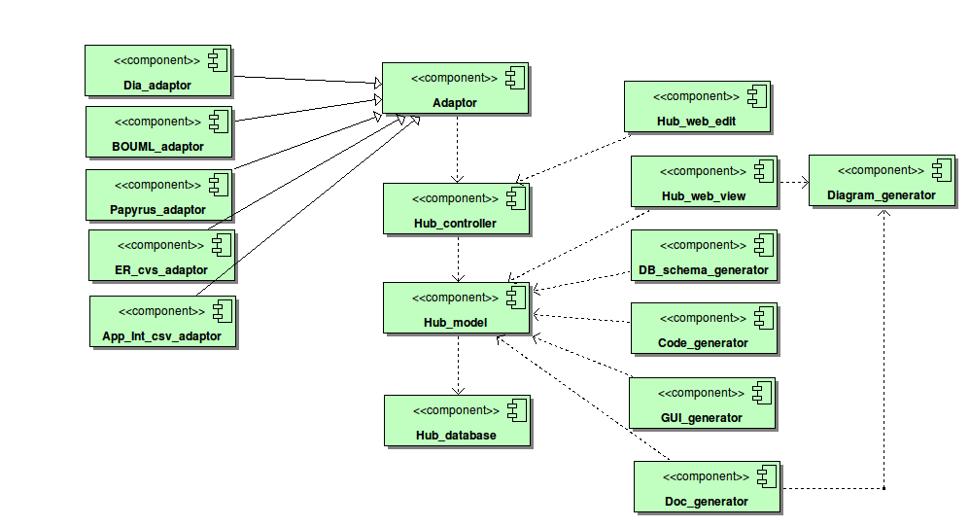

Human-Computer Interface
(Discussion, performance targets, mockups, etc.)
TBD

Infrastructure Architecture
(Security, data volume and change rates, number of total users and concurrent users, transaction rates, firewalls, Deployment Diagrams)

Security: Pycase itself only requires that the project (documentaiton, code etc.) is controlled by development team. Rqmts for a project generated/managed by pycase depend on the project. Assume we must at least support encrypted data-at-rest, encrypted channels, and user authentication/authorization.
Data Volume: Worst case:
1,000 Entities (10 Attributes each); 5,000 Relationships. 10 changes/week
1,000 Business_processes; 5,000 Business_workflows 100 changes/week
1,000 Applications, 2000 App_versions, 2,000 App_Packages, 5,000 App_installations. 100 changes/week
5,000 Interfaces, 10,000 Int_versions. 1000 changes/week
10,000 Servers; 50,000 channels. 1000 changes/week

Best case: 10% of worst case.

Editors (of PyCase data): 1000 total; 100 concurrent
Viewers: 10,000 total; 1,000 concurrent

Testing

Test Strategy
(Automated regression tests? Require manual test scripts? Test function, scalability?)
- Use User Rqmts to validate Processes.
- Use Processes to generate test cases
- Capture test cases for Hub editing as automated regression test harness, driven at level of Controller
- Capture test cases for Adapters as roundtrip tools-to-hub-to-tool.
- Capture test cases for Generators as known-hub-state-to-outputs (with known-good output oracles)

Test Suite
(Actual tests, or reference to them)

